Mar 29, 2023

Meeting minutes

Author: Abiodun Adeoye, GSO Recording Secretary, 2022-2023

Executive Summary

On Wednesday, March 29, 2023, the Graduate Student Organization held its seventh regular meeting of the 2022-2023 academic year in Lyman Hall, room 132 at 5:30 PM. At the meeting, Dr. Jamie Winders presented on the draft of Syracuse University’s Academic Strategic Plan for the next five years. The Senate also voted to approve a special funding request from the Religion Graduate Organization and passed three resolutions: one to recognize Memorial Day, one to recognize Asian American, Native Hawaiian, and Pacific Islander Heritage Month, and one to recognize Lesbian, Gay, Bisexual, Transgender, Queer, and Intersex Pride Month.
The Diversity, Equity, Inclusion, and Accessibility (DEIA) Committee and the Professional, Academic, and Creative (PAC) Grant Committee gave their reports to the Senate. The chair of the PAC Grant Committee motioned for the budget of the PAC Grant program to be raised to a minimum of $60,000 for the upcoming 2023-2024 school year. The motion was referred to the Finance Committee. Senator Dominic Wilkins motioned to strike the letter of recommendation requirements on the PAC Grant application. The motion was referred to the PAC Grant Committee to discuss and report back at the next regular meeting on Apr 26, 2023.
The Interim President/Vice President of Internal Affairs, the Vice President of External Affairs, and the Comptroller also gave reports. The Interim President/Vice President of Internal Affairs report detailed plans to conduct a periodic review of the GSO Policy Platform, announced the RGSO renewal process, called for applications regarding the open graduate position on the Community Review Board, and reported on the activities of the Rules & Administration Special Committee as well as on the first meeting of the newly created Executive Board Advisory Council, among other things. The Comptroller’s report detailed the expenses for operating expenses, the PAC Grant program, GSO Special Programming, Registered Student Organization expenses, special programming, and a $12 Comptroller error. The Vice President of External Affairs reported on the status of the plan for the GSO picnic and negotiations with SU Catering. GSO Trivia Night will be on April 18 from 6:30 PM to 9:30 PM, and the GSO Senator and Committee Members Appreciation Night will be on April 28 at Drumlins from 7 PM to 10 PM.

The next GSO Regular Senate Meeting will be held on Apr 26, 2023 in Lyman Hall, room 132 at 5:30 PM.

Votes:

- Motion to extend SUNY ESF Graduate Student Fee Inquiry – 6:49 PM
  - Vote: 33 Yes, 2 No, 1 Abstentions
- Special Funding Request: Religion Graduate Organization – 6:56 PM
  - Vote: 33 Yes, 3 No, 0 Abstentions
- GSO Senate Resolution 23.08: A Resolution to Recognize Memorial Day – 8:25 PM
  - Vote: 17 yes 5 no, 6 abstentions
- GSO Senate Resolution 23.09: A Resolution to Recognize Asian American, Native Hawaiian, and Pacific Islander Heritage Month – 8:33 PM
  - Vote: 24 yes, 0 no, 3 abstentions
- GSO Senate Resolution 23.10: A Resolution to Recognize Lesbian, Gay, Bisexual, Transgender, Queer, and Intersex Pride Month – 8:36 PM
  - Vote: 31 yes, 0 no, 0 abstentions
- Call to order – 5:40 PM
  - 36 present
- Academic strategic plan – 5:43 PM (appendix A)
  - Presenter: Dr. Jamie Winders
  - Questions – 5:53 PM
  - Concluded at 6:08 PM
- Interim President/IVP report – 6:10 PM (appendix B)
  - See appendix B below.
- EVP report – 6:19 PM (appendix C)
  - Click here for the full report
- Comptroller’s report – 6:36 PM (appendix D)
  - Click here for the full report
  - See appendix D for the report in text version
- Motion to extend ESF Graduate Student Fee Inquiry – 6:49 PM
  - Vote: 33 Yes, 2 No, 1 Abstention
- Special funding request – Religion Graduate Organization – 6:56 PM (appendix E)
  - Summary: The Religion Graduate Organization requested $1,631 from the GSO for the Religion department’s annual spring speaker event. More details in appendix E
  - Vote: 33 yes, 3 no, 0 abstain
- Diversity, Equity, Inclusion, and Accessibility (DEIA) Committee Report – 7:18 PM (appendix F)
  - Committee members:
    - Kellin Tasber, Chair
    - Kirin Taylor, Vice Chair
    - Lahari Chowtoori and Ben Valen, Committee Members
- Professional, Academic, and Creative Travel Grant (PAC Grant) Committee Report – 7:50 PM (appendix G)
  - Presenters: Abiodun Adeoye (Recording Secretary and PAC Grant Chair), and Roger Rosena (PAC Grant Committee Vice Chair)
  - Important links:
    - Click here to view the full presentation
    - Click here to view the PAC Grant Application Experience Survey
    - Click here to view the survey results
- GSO Senate Resolution 23.08: A Resolution to Recognize Memorial Day – 8:25 PM (appendix H)
  - Vote: 17 yes 5 no, 6 abstain
- Resolution 23.09: A Resolution to Recognize Asian American, Native Hawaiian, and Pacific Islander Heritage Month – 8:33 PM (appendix I)
  - Vote: 24 yes, 0 no, 3 abstain
- Resolution 23.10: A Resolution to Recognize Lesbian, Gay, Bisexual, Transgender, Queer, and Intersex Month – 8:36 PM (appendix J)
  - Amended & Senator sponsors added.
  - 31 yes, 0 no, 0 abstentions
- Motion to strike the PAC Grant recommendation letter – 8:58 PM
  - Motioned by APS Senator Dominic Wilkins and reads thus: "To prohibit the PAC Grant committee from considering letters of recommendation as part of the application process".
- Motion to refer the recommendation to the PAC Grant committee to decide on and report back at the next regular meeting – 9:10 PM
  - Motioned by APS Biology CJ Arnell
  - Votes: 24 yes, 3 no, 2 abstain
- Announcements and remarks for the record – 9:12 PM
  - Get RGSO application in before finance committee sets the budget.
- Motion to adjourn the meeting – 9:22 PM
- Adjourned at 9:22 PM
Appendix A

Click here to view the Academic Strategic Plan Draft Framework

Appendix B

Interim President/Vice President of Internal Affairs Report
- Review of the GSO Policy Platform is ongoing. So far received official recommendations from the Climate Action Committee. Still waiting to receive any further recommendations from other committees before putting together a Resolution to revise.
- The GSO Constitution has been updated in accordance with SR 23.05 (passed on February 1st) and has been double-checked by the Rules and Administration Special Committee members. The new edition has been uploaded to the website.
- The RGSO Renewal Process was announced to all registered RGSO officers on March 20th. The deadline to submit RGSO renewal applications is April 7th. If an RGSO does not apply in time, or fails to apply at all, they will need to apply as a New RGSO next year. Please urge your RGSOs to submit renewals in a timely manner.
- Collecting applications to appoint a graduate student to the Community Review Board. The CRB consists of 11 community members and reviews appeals of civilian complaints regarding the Department of Public Safety (DPS) officer conduct, current and prospective DPS policies, procedures and trainings, and key community-facing functions of the DPS. The current Chair of the CRB sent out the call for applications on March 24th. The deadline to submit applications is Friday, March 31st, and individuals selected will be notified on April 14th. Interim President has received only two applications so far. Please promulgate this information to your colleagues and encourage anyone interested to apply in order to ensure that we have a strong pool of candidates to select from. Interim President will report the results of the appointment at the next regular meeting.
- The Rules and Administration special committee is compiling a running document annotating any portions of the GSO Constitution that are ambiguous, unclear, or need updating and clarifying. Ultimately, the hope is that R&A will host a “constitutional convention” of Senators next year to iron out and update any deficiencies as a deliberative assembly. Additionally, R&A has been working on creating a Senate Legislative Record (SLR), a short-hand compendium of the various Resolutions passed by the GSO in this and previous years (as far as we know them). The hope is to provide a Quick Reference Guide for members of the deliberative assembly to bolster the GSO’s institutional memory despite membership turnover, instead of relying solely on information passed down member to member. If successful, it may help our organization keep better keep track of legislation that is still in effect (standing legislation) from year to year and provide an accessible, empowering tool for future deliberative assembly members.
- The Executive Board Advisory Council held its inaugural meeting over Spring Break on March 15th. The minutes were sent to the Senate. The EBAC operated well, providing robust communication, transparency, and accountability between our committees and executive board. Each committee representative gave a lightning round of brief, efficient reports on their ongoing committee work, providing the opportunity for committee representatives and executive board members to network with one another on projects and action items. Already it has provided some excellent results, such as, for example, sparking the production of an International/Non-Resident Alien Tax Witholding statement (still under review) containing information and linked resources to be posted on the GSO website.

Appendix C

Vice President of External Affairs Report

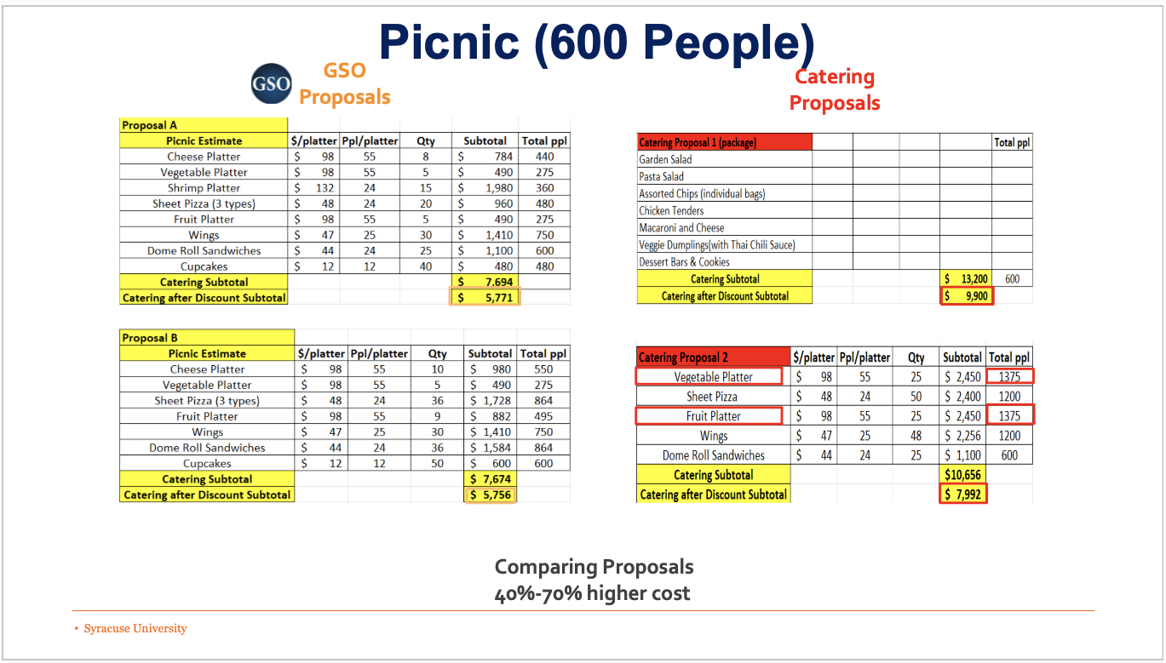

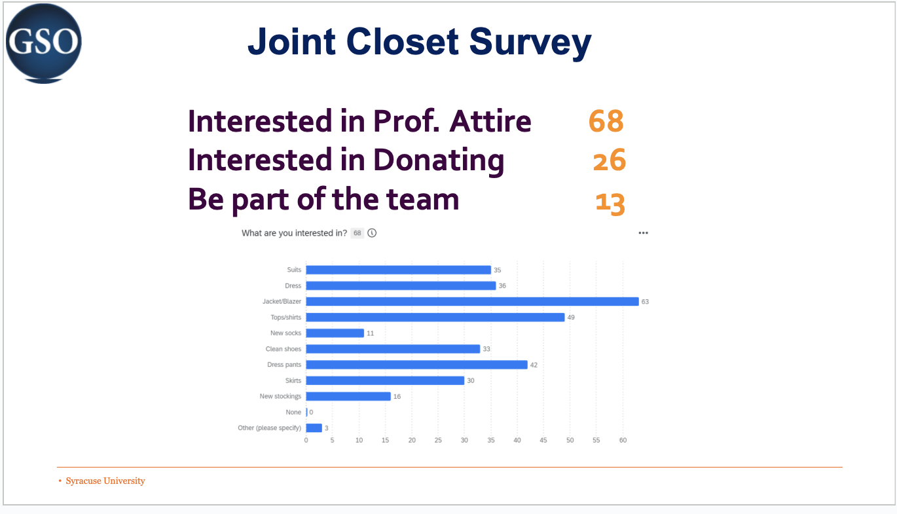

Appendix D

Comptroller’s Report

This report serves as a written account of the major expenses that occurred and were reconciled between the last Senate report (March 1) and the current report (March 29).

The format of the report will conform to the following structure:

Outlay Type: Amount of Money in Cash Spent Over the Reporting Period
Written explanation of the expenses.

Note: The expenses reported herein and recorded in the “Simplified Budget” are reconciled with the General Ledger’s most recent monthly Journal Report (February). There may be expenses that have occurred but are not represented here as they have not been reconciled yet.

Operating Expenses: $14,829.21
The major “expense” in this category was the reallocation of the GSO President’s remaining pay to the Special Programming line item ($9012.50). This reallocation explains the sharp increase in Cash in Special Programming from the last report, and the very low decrease in Accrual obligations relative to the Special Programming funds approved in the last Senate meeting. The recurring monthly pay for all Executive Board members is now $4,329.34, with the President’s monthly pay of $1,802.50 no longer applied. The large Acc/Cash Difference ($14,017.48) in this outlay type is accounting for the obligation to pay Executive Board compensation and tracking the monthly stipends still to be paid. Office expenses ($20.42), Senate Meeting Food for February ($471.21), Committee Expenses tax adjustment ($18.24), and CART Services for February and March ($977.50) all account for the remainder.

Grant Program: $7,943.37
This accounts for all the PAC Grants reimbursed over the reporting period. The total value of grants awarded to date but not yet reimbursed is the Acc/Cash Difference of this outlay type ($11,264.91).

GSO Programming: $774.99
This outlay type covers the expenses of the External Vice President. The expenses reconciled for this period are the DJ for the GSO Mixer Event ($750) and Wrist Straps purchased for the event ($24.99).

Registered Student Organization Expenses: $4,253.82
This outlay type covers the combined expenses reimbursed for both the Academic and Non-Academic RSOs. The Acc/Cash Difference of both Academic ($18,866.53) and Non-Academic RSOs ($331.75) represents the amount of money set aside for RSO expenses and not yet reimbursed.

Special Programming: $0
This outlay type covers expenses directly approved by the Senate. No Special Programming events took place in the reporting period. However, please note that the Special Programming Cash line actually increased by $12,299.50. This increase is the reallocation of the GSO President’s stipend and the Annual budgets of RSOs that stated they would use them to supplement their request.

Comptroller Error: $12
The GEOGO Special Programming application approved at the last meeting noted that the RSO had $962 in its Annual Budget, but it only had $950. The Comptroller did not catch the error until after approval. The errant $12 is drawn from Miscellaneous Expenses.

Appendix E

Religion Graduate Organization Special Funding Request

Title of Event(s): Spring Speaker

Description of Event(s): The speaker event is an annual event that's been organized by the RGO for several years now. We invite a religious studies scholar from another institution to deliver a workshop and a public lecture. The RGO collectively chooses who to invite and this year we chose Dr. Noreen Khawaja, from Yale. She's an important philosopher of religion and intellectual historian. Although her work clearly appeals mostly to religious studies students, her work will most definitely attract attention from students in departments like History or Philosophy. The speaker is invited to two events: i) a small workshop open only to religion graduate students in which we workshop with the scholar a part of their current research; ii) a public lecture that is open to all graduate students and the SU community.

How will this event/these events serve your constituency, and further the goals of your organization? This event will allow religion students to listen to the current work from an important and active religious studies scholar. It will allow students to network, exchange ideas, and gain experience organizing academic events of this nature. It will also continue to position Syracuse University as an important institution for religious studies

How does this event/these events benefit the graduate community at Syracuse University? It will allow students and faculty from various departments to hear the current work of an important active religious studies scholar.

Total Costs: $3,531.00

Total GSO Account Balance: $775.00

GSO Annual Budget Funds Remaining: $663.86

Total Request from GSO: $1,631.00

Appendix F

DEIA Committee Report

The GSO DEIA Committee gathered information about three groups of marginalized identities; international students, LGBTQ+ students, and students that are differently abled or need accommodations. Within these groups, committee members worked to make resources for people with these identities that would have information like what sort of spaces are friendly and where to get medical care or groceries that are affordable. Another project of the DEIA Committee was to begin working on a survey to better assess diverse communities and their experience here at Syracuse University. Beyond that, the Chair and Vice Chair have engaged in a wide variety of meetings to 1. begin making connections for the DEIA Committee to use in the future and 2. advocate to the best of our ability the voices that have brought concerns to us.

Click here to view the full report in PowerPoint

Appendix G

Professional, Academic, and Creative Travel Grant (PAC Grant) Committee Presentation

Committee members throughout the 2022-2023 academic year:

- Abiodun Adeoye – Chair
- Roger Rosena – Vice Chair
- Samaya Nasr
- Ian Glazman-Schillinger
- Austin Lewter
- Qingyang Liu
- Erin O’Daniel
- Cassidy Thomas
- Aditya Hartalkar
- Diana Brown
- Ibrahim Kizil
- John Abercrombie
- Dimpy Ghaswala
- Harshit Sharma

2022-2023 Totals (up to Mar 29, 2023):

- September – 30 apps; $13,991.06 requested; $10,937 awarded
- October – 23 apps; $12,834 requested; $9,100 awarded
- November – 18 apps; $9,391.21 requested; $8,098 awarded
- Dec. and Jan. – 20 apps; $9,025.43 requested; $6,740 awarded
- February – 27 apps; $13,192 requested; $11,392.37 awarded
- March – 29 apps; $13,932.73 requested;
- Academic year totals – 147 apps; $72,366.43 requested; $46,267.37 awarded
Total and average expenses per month (conference costs)
- September –$41,282.95 total; applicants spent a minimum of $199 and a maximum of $3,634.92
- October – $25,082.50 total; applicants spent a minimum of $100.00 and maximum of $1,930.00
- November – $22,410.49 total; applicants spent a minimum of $500 and a maximum of $3,300
- December and January – $40,452.69 total; applicants spent a minimum of $180 and a maximum of $2,325.59
- February – $33,478.75 total; applicants spent a minimum of $349 and a maximum of $3,388.99
- March – $33,623.07 total; applicants spent a minimum of $400 and a maximum of $3,000
- April – To be determined
PAC Grant Experience Survey
- Link to the survey
  - Survey components:
    - Name
    - SU email
    - Program
    - Master’s or PhD student
    - International student?
    - For what month did you submit a PAC Grant application?
    - How would you describe your PAC Grant Application experience?
    - Approximately how much was your travel cost?
    - Approximately what percentage of your travel did the PAC Grant cover?
    - Did you receive any funding from your department or other sources?
    - If you received funding from your department/an outside source, how much of your travel did it cover?
    - What types of expenses did your travel cost cover for the most part?
    - Did you have any trouble filling out the PAC Grant application?
    - In what ways do you think the GSO can improve the PAC Grant application for coming years?
    - The PAC Grant currently funds students in a range of $50-500. What are your thoughts on this range? Is it sufficient? Insufficient?
    - Any other thoughts/opinions?
- Link to full results
  - 48 respondents
  - 75% PhD, 25% Masters
  - 52.1% international students, 45.8% domestic students
  - Application experience: 31.3% very good, 45.8% good, 16.7% fair, 6.3% poor
  - Travel costs: 47.9% spent more than $1,000; over 90% spent over $500
  - PAC Grant travel cover: covered 30-40% for 31.3% of respondents, 20-30% for 22.9% of respondents
  - Department/outside funding: 66.7% yes, 33.3% no
Committee efforts to assist applicants:
- Application recommendations document
- Ideas discussed within the committee:
  - Grading applications over the summer
  - Recording a webinar for applicants by September 2023
Recommendations for 2023-2024
- Budget increase – Abiodun
  - 2022-2023 budget: $31,277
- Award minimum and maximum increase – Abiodun
  - Current: $50-500
  - Recommended increase: $300-1000
Appendix H

GSO Senate Resolution 23.08
A Resolution to Recognize Memorial Day
Author(s): Gabriel Uy (APS Business Administration, Army Officer)
Sponsor(s): Kellin Tasber (University Senator, DEIA Committee Chair), Richard Kaufman IV (Senator-At-Large), Di Wu (MBA/EMPA, Army Officer), Bong Chi (MBA/EMPA, Army Officer), Dominque Gibson (MBA/EMPA, Army Civilian), Ron Rider (MBA/EMPA, Army Civilian), Leslie Ann Tamez (MBA/EMPA, Army NCO)
Date(s): 29 March 2022 (Voting Date)
Action(s):
Chair of the Senate: Daniel J. Kimmel
President Pro Tempore of the Senate: Vito Iaia
Parliamentarian: Zafar Ali
President of the Student Body: Daniel J. Kimmel (Interim)

Whereas, Memorial Day is nationally recognized in the United States that is observed on the last Monday of May as a day of prayer for permanent peace and a day for mourning American military personnel who died while serving in the Armed Forces of the United States; and
Whereas, Memorial Day was first called “Decoration Day” because communities across America honored those died in war by decorating their graves with flowers, and red poppies are an emblem of “keeping the faith with all who died;” and
Whereas, the United States Congress, by Public Law 106-579, designated 3:00 p.m. local time on Memorial Day as a time for all Americans to observe the National Moment of Remembrance; and
Whereas, Syracuse is home to 5,212 veterans as of the 2020 Census and Syracuse University is proud to currently enroll more than 1,000 veteran and military-connected students; and
Whereas, This year Syracuse University observes Memorial Day on May 29, 2023 and University offices will be closed; therefore, be it
Resolved, that the GSO encourages all students and the Syracuse community to commemorate Memorial Day and the patriots who gave their lives in the service to America through appropriate ceremonies and activities; and be it
Resolved, that the GSO supports Syracuse University’s commemorative expressions and programs for Memorial Day; and be it
Resolved, that the GSO includes in its calendar and share on its social media accounts Memorial Day event information of Syracuse University; and be it
Resolved, that copies of this resolution be distributed by the GSO Interim President to: the Chancellor, the Provost, the Board of Trustees, the Dean of the Graduate School and the Dean of Students, the University Senate, the Undergraduate Student Association, the Office of Veterans and Military Affairs, the National Veterans Resource Center, and other interested entities.

Appendix I

GSO Senate Resolution 23.09
A Resolution to Recognize Asian American, Native Hawaiian, and Pacific Islander Heritage Month
Author(s): Gabriel Uy (APS Business Administration)
Sponsor(s): Daniel J. Kimmel (GSO Interim President & Vice President of Internal Affairs), Kellin Tasber (University Senator, DEIA Committee Chair), Kirin Taylor (APS Political Science, DEIA Committee Vice-Chair), Richard Kaufman IV (Senator-At-Large)
Date(s): 29 March 2023 (Voting Date)
Action(s):
Chair of the Senate: Daniel J. Kimmel
President Pro Tempore of the Senate: Vito Iaia
Parliamentarian: Zafar Ali
President of the Student Body: Daniel J. Kimmel (Interim)

Whereas, during Asian American, Native Hawaiian, and Pacific Islander (AANHPI) Heritage Month each May, the United States recognizes and celebrates the many contributions and vibrant cultures of Asian Americans, Native Hawaiians, and Pacific Islanders; and
Whereas, Syracuse University offers an interdisciplinary minor in Asian and Asian American Studies that was formed under founding director Professor Prema Kurien as a result of student activism, and it examines the histories and cultures of Asia, contemporary Asia, and how American politics, capital, religion, culture and Asian American diasporas have shaped the United States and Asia. The program offers more than 30 courses on campus and abroad; and
Whereas, under the leadership of Chancellor Kent Syverud, Syracuse University’s commitment to diversity and inclusion is rooted in the belief that multiple points of view, life experiences, ethnicities, cultures, and belief systems are essential to academic excellence, and he created the Chancellor's Workgroup on Diversity and Inclusion to create a more diverse and inclusive climate at Syracuse; and
Whereas, Syracuse is home to more than 10,300 people of AANHPI descent as of the 2020 Census and Syracuse University is proud to currently enroll more than 900 students of AANHPI descent; and
Whereas, Syracuse University’s Office of Multicultural Affairs AAPI Heritage Month Committee is hosting various events on campus starting with a kick-off on Friday, March 31 at 4pm in the Schine Atrium; therefore, be it
Resolved, that the GSO encourages all students and the Syracuse community to commemorate AANHPI Heritage Month through appropriate ceremonies and activities; and be it
Resolved, that the GSO supports Syracuse University’s commemorative expressions and programs for AANHPI Heritage Month; and be it
Resolved, that the GSO includes in its calendar and share on its social media accounts the event information of the Syracuse University’s Office of Multicultural Affairs’ 2023 AAPI Heritage Month Committee; and be it
Resolved, that copies of this resolution be distributed by the GSO Interim President to: the Chancellor, the Provost, the Board of Trustees, the Dean of the Graduate School and the Dean of Students, the University Senate, the Undergraduate Student Association, the office of Diversity and Inclusion, and other interested entities.

Appendix J

GSO Senate Resolution 23.10
A Resolution to Recognize Lesbian, Gay, Bisexual, Transgender, Queer, And Intersex Pride Month
Author(s): Gabriel Uy (APS Business Administration)
Sponsor(s): Daniel J. Kimmel (GSO Interim President & Vice President of Internal Affairs), Kellin Tasber (University Senator, DEIA Committee Chair), Kirin Taylor (APS Political Science, DEIA Committee Vice-Chair), Richard Kaufman IV (Senator-At-Large)
Date(s): 29 March 2023 (Voting Date)
Action(s):
Chair of the Senate: Daniel J. Kimmel
President Pro Tempore of the Senate: Vito Iaia
Parliamentarian: Zafar Ali
President of the Student Body: Daniel J. Kimmel (Interim)

Whereas, during Lesbian, Gay, Bisexual, Transgender, Queer, and Intersex (LGBTQI+) Pride Month each June, we reflect on the progress we have made and the journey we have traversed in the fight for justice, inclusion, and equality while we recommit ourselves to unfinished work left to do in and beyond our campus community; and
Whereas, the Syracuse University Lesbian, Gay, Bisexual, Transgender and Queer Resource Center seeks to be a campus and regional leader delivering support, community and education around marginalized genders and sexualities, and the complex intersections of our multiple identities, and spearheads LGBTQ+ History Month with events on campus throughout the month of October; and
Whereas, under the leadership of Chancellor Kent Syverud, Syracuse University’s commitment to diversity and inclusion is rooted in the belief that multiple points of view, life experiences, ethnicities, cultures, and belief systems are essential to academic excellence, and he created the Chancellor's Workgroup on Diversity and Inclusion to create a more diverse and inclusive climate at Syracuse; and
Whereas, Syracuse University offers an interdisciplinary minor in LGBTQ Studies that is open and welcoming to all students and offers a sustained opportunity to learn about LGBTQ experience, history and scholarship, explore fundamental questions about sexualities, bodies, identities, communities, social movements and liberation politics, and has classes offered abroad in London, Madrid, and Poland; therefore, be it
Resolved, that the GSO encourages all students and the Syracuse community to commemorate LGBTQ+ Pride Month through appropriate ceremonies and activities; and be it
Resolved, that the GSO supports Syracuse University’s commemorative expressions and programs for LGBTQ+ persons; and be it
Resolved, that the GSO includes in its calendar and share on its social media accounts LGBTQI+ Pride event information of Syracuse University; and be it
Resolved, that copies of this resolution be distributed by the GSO Interim President to: the Chancellor, the Provost, the Board of Trustees, the Dean of the Graduate School and the Dean of Students, the University Senate, the Undergraduate Student Association, the office of Diversity and Inclusion, the LGBTQ Resource Center, and other interested entities.

As of March 29, 2023, there was no amount total awarded for the PAC Grant applications for the month of March because the committee was still in the midst of grading applications submitted for March.
The results are as of March 29, 2023.

